**(NATIONAL TECHNOLOGY DAY)**

Introduction to Engineering:-

Engineering is the designing, testing and building of machines, structures and processes using of Maths and science.

**History**

Engineering has existed since ancient times, when [humans](https://en.wikipedia.org/wiki/Humans) devised inventions such as the wedge, lever, wheel and pulley, etc.

The term *engineering* is derived from the word *engineer*, which itself dates back to the 14th century when an *engineer* (literally, one who builds or operates a [*siege engine*](https://en.wikipedia.org/wiki/Siege_engine)) referred to "a constructor of military engines".[[7]](https://en.wikipedia.org/wiki/Engineering#cite_note-7) In this context, now obsolete, an "engine" referred to a military machine, *i.e.*, a mechanical contraption used in war (for example, a [catapult](https://en.wikipedia.org/wiki/Catapult)). Notable examples of the obsolete usage which have survived to the present day are military engineering corps, *e.g.*, the [U.S. Army Corps of Engineers](https://en.wikipedia.org/wiki/United_States_Army_Corps_of_Engineers).

The word "engine" itself is of even older origin, ultimately deriving from the Latin *ingenium* (c. 1250), meaning "innate quality, especially mental power, hence a clever invention. buildings, matured as a technical discipline, the term [civil engineering](https://en.wikipedia.org/wiki/Civil_engineering)[[6]](https://en.wikipedia.org/wiki/Engineering#cite_note-ECPD_Definition_on_Britannica-6) entered the lexicon as a way to distinguish between those specializing in the construction of such non-military projects and those involved in the discipline of [military engineering](https://en.wikipedia.org/wiki/Military_engineering).

Ancient Era

The [pyramids](https://en.wikipedia.org/wiki/Egyptian_pyramids) in [ancient Egypt](https://en.wikipedia.org/wiki/Ancient_Egypt), [ziggurats](https://en.wikipedia.org/wiki/Ziggurats) of [Mesopotamia](https://en.wikipedia.org/wiki/Mesopotamia), the [Acropolis](https://en.wikipedia.org/wiki/Acropolis_of_Athens) and [Parthenon](https://en.wikipedia.org/wiki/Parthenon) in Greece, the [Roman aqueducts](https://en.wikipedia.org/wiki/Roman_aqueduct), [Via Appia](https://en.wikipedia.org/wiki/Via_Appia) and Colosseum, [Teotihuacán](https://en.wikipedia.org/wiki/Teotihuac%C3%A1n), and the [Brihadeeswarar Temple](https://en.wikipedia.org/wiki/Brihadeeswarar_Temple" \o "Brihadeeswarar Temple) of [Thanjavur](https://en.wikipedia.org/wiki/Thanjavur" \o "Thanjavur), among many others, stand as a testament to the ingenuity and skill of ancient civil and military engineers. Other monuments, no longer standing, such as the [Hanging Gardens of Babylon](https://en.wikipedia.org/wiki/Hanging_Gardens_of_Babylon) and the [Pharos of Alexandria](https://en.wikipedia.org/wiki/Pharos_of_Alexandria), were important engineering achievements of their time and were considered among the [Seven Wonders of the Ancient World](https://en.wikipedia.org/wiki/Seven_Wonders_of_the_Ancient_World).

The six classic [simple machines](https://en.wikipedia.org/wiki/Simple_machines) were known in the [ancient Near East](https://en.wikipedia.org/wiki/Ancient_Near_East). The [wedge](https://en.wikipedia.org/wiki/Wedge_(mechanical_device)) and the [inclined plane](https://en.wikipedia.org/wiki/Inclined_plane) (ramp) were known since [prehistoric](https://en.wikipedia.org/wiki/Prehistoric) times.[[9]](https://en.wikipedia.org/wiki/Engineering#cite_note-9) The [wheel](https://en.wikipedia.org/wiki/Wheel), along with the [wheel and axle](https://en.wikipedia.org/wiki/Wheel_and_axle) mechanism, was invented in [Mesopotamia](https://en.wikipedia.org/wiki/Mesopotamia) (modern Iraq) during the 5th millennium BC.[[10]](https://en.wikipedia.org/wiki/Engineering#cite_note-10) The [lever](https://en.wikipedia.org/wiki/Lever) mechanism first appeared around 5,000 years ago in the [Near East](https://en.wikipedia.org/wiki/Near_East), where it was used in a simple [balance scale](https://en.wikipedia.org/wiki/Balance_scale),[[11]](https://en.wikipedia.org/wiki/Engineering#cite_note-Paipetis-11) and to move large objects in [ancient Egyptian technology](https://en.wikipedia.org/wiki/Ancient_Egyptian_technology).[[12]](https://en.wikipedia.org/wiki/Engineering#cite_note-12) The lever was also used in the [shadoof](https://en.wikipedia.org/wiki/Shadoof" \o "Shadoof) water-lifting device, the first [crane](https://en.wikipedia.org/wiki/Crane_(machine)) machine, which appeared in Mesopotamia c. 3000 BC,[[11]](https://en.wikipedia.org/wiki/Engineering#cite_note-Paipetis-11) and then in of [pulleys](https://en.wikipedia.org/wiki/Pulley) date back to Mesopotamia in the early 2nd millennium BC,[[14]](https://en.wikipedia.org/wiki/Engineering#cite_note-Eisenbrauns-14) and [ancient Egypt](https://en.wikipedia.org/wiki/Ancient_Egypt) during the [Twelfth Dynasty](https://en.wikipedia.org/wiki/Twelfth_Dynasty_of_Egypt) (1991–1802 BC).[[15]](https://en.wikipedia.org/wiki/Engineering#cite_note-15) The [screw](https://en.wikipedia.org/wiki/Screw_(simple_machine)), , the inclined plane, the wedge, and the lever, to create structures like the [Gr](https://en.wikipedia.org/wiki/Great_Pyramid_of_Giza)eat pyramid of Giza.

**Modern Era**

The science of [classical mechanics](https://en.wikipedia.org/wiki/Classical_mechanics), sometimes called Newtonian mechanics, formed the scientific basis of much of modern engineering.[[44]](https://en.wikipedia.org/wiki/Engineering#cite_note-Robinson-Musnon-44) With the rise of engineering as a [profession](https://en.wikipedia.org/wiki/Profession) in the 18th century, the term became more narrowly applied to fields in which mathematics and science were applied to these ends. Similarly, in addition to military and civil engineering, the fields then known as the [mechanic arts](https://en.wikipedia.org/wiki/Mechanic_arts) became incorporated into engineering.

Canal building was an important engineering work during the early phases of the Industrial Revolution.[[45]](https://en.wikipedia.org/wiki/Engineering#cite_note-45)

[John Smeaton](https://en.wikipedia.org/wiki/John_Smeaton) was the first self-proclaimed civil engineer and is often regarded as the "father" of civil engineering. He was an English civil engineer responsible for the design of bridges, canals, harbors, and lighthouses. He was also a capable [mechanical engineer](https://en.wikipedia.org/wiki/Mechanical_engineer) and an eminent [physicist](https://en.wikipedia.org/wiki/Physicist). Using a model water wheel, Smeaton conducted experiments for seven years, determining ways to increase efficiency.[[46]](https://en.wikipedia.org/wiki/Engineering#cite_note-University_Of_Chicago_Press-46): 127 Smeaton introduced iron axles and gears to water wheels.[[44]](https://en.wikipedia.org/wiki/Engineering#cite_note-Robinson-Musnon-44): 69 Smeaton also made mechanical improvements to the [Newcomen steam engine](https://en.wikipedia.org/wiki/Newcomen_atmospheric_engine). Smeaton designed the third [Eddystone Lighthouse](https://en.wikipedia.org/wiki/Eddystone_Lighthouse" \o "Eddystone Lighthouse) (1755–59) where he pioneered the use of '[hydraulic lime](https://en.wikipedia.org/wiki/Hydraulic_lime)' (a form of [mortar](https://en.wikipedia.org/wiki/Mortar_(masonry)) which will set under water) and developed a technique involving dovetailed blocks of granite in the building of the lighthouse. He is important in the history, rediscovery of, and development of modern [cement](https://en.wikipedia.org/wiki/Cement), because he identified the compositional requirements needed to obtain "hydraulicity" in lime; work which led ultimately to the invention of the Portland cement.

**Main Branches of Engineering**

1. **Chemical engineering:-**

Chemical engineering is the application of physics, chemistry, biology, and engineering principles in order to carry out chemical processes on a commercial scale.





1. **Civil engineering:-**

Civil engineering is the design and construction of public and private works, such as [infrastructure](https://en.wikipedia.org/wiki/Infrastructure) (airports, roads, railways, water supply, and treatment etc.), bridges, tunnels, dams, and buildings.[[59]](https://en.wikipedia.org/wiki/Engineering#cite_note-59)[[60]](https://en.wikipedia.org/wiki/Engineering#cite_note-60) Civil engineering is traditionally broken into a number of sub-disciplines, including [structural engineering](https://en.wikipedia.org/wiki/Structural_engineering), [environmental engineering](https://en.wikipedia.org/wiki/Environmental_engineering), and [surveying](https://en.wikipedia.org/wiki/Surveying). It is traditionally considered to be separate from [military engineering](https://en.wikipedia.org/wiki/Military_engineering).

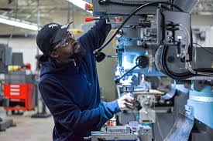

1. **Mechanical engineering:-**

Mechanical engineering is the design and manufacture of physical or mechanical systems, such as power and [energy](https://en.wikipedia.org/wiki/Energy) systems, [aerospace](https://en.wikipedia.org/wiki/Aerospace)/[aircraft](https://en.wikipedia.org/wiki/Aircraft) products, [weapon systems](https://en.wikipedia.org/wiki/Weapon_systems), [transportation](https://en.wikipedia.org/wiki/Transportation) products, [engines](https://en.wikipedia.org/wiki/Internal_combustion_engine), [compressors](https://en.wikipedia.org/wiki/Gas_compressor), [powertrains](https://en.wikipedia.org/wiki/Powertrain), [kinematic chains](https://en.wikipedia.org/wiki/Kinematic_chain), vacuum technology, [vibration isolation](https://en.wikipedia.org/wiki/Vibration_isolation) equipment, [manufacturing](https://en.wikipedia.org/wiki/Manufacturing), robotics, turbines, audio equipments, and [mechatronics](https://en.wikipedia.org/wiki/Mechatronics).



1. **Bioengineering :-**

Bioengineering is the engineering of biological systems for a useful purpose. Examples of bioengineering research include bacteria engineered to produce chemicals, new medical imaging technology, portable and rapid disease diagnostic devices, prosthetics, biopharmaceuticals, and tissue-engineered organ.

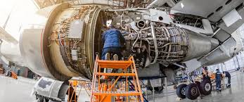

1. **Aerospace Engineering:-**

The [*InSight*](https://en.wikipedia.org/wiki/InSight) lander with solar panels deployed in a cleanroom.

Aerospace engineering covers the design, development, manufacture and operational behavior o[aircraft](https://en.wikipedia.org/wiki/Aircraft" \o "Aircraft), [satellites](https://en.wikipedia.org/wiki/Satellite) and [rockets](https://en.wikipedia.org/wiki/Rocket).

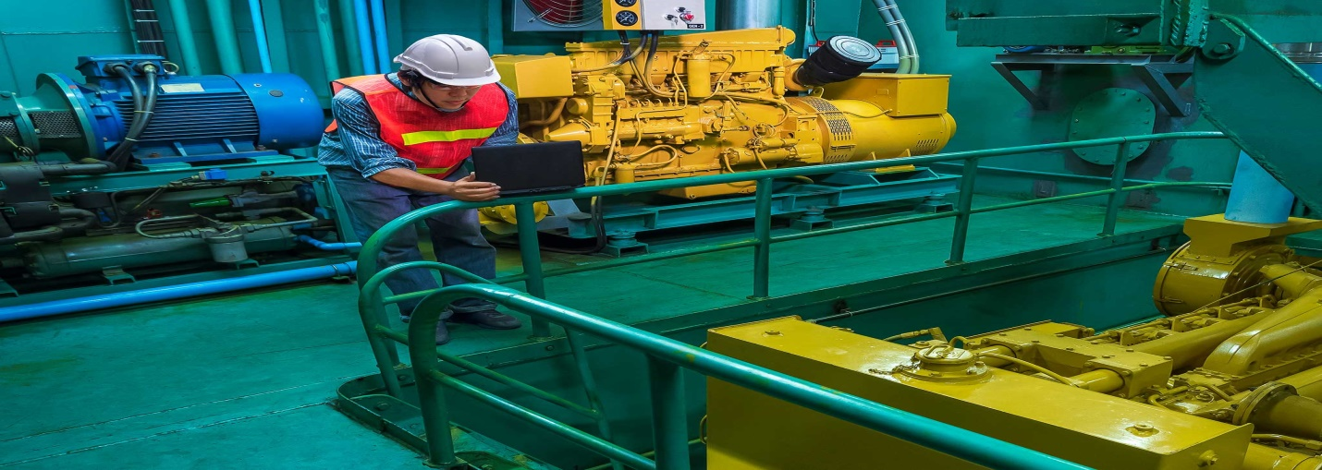

1. **Marine Engineering:-**

Marine engineering covers the design, development, manufacture and operational behaviour of [watercraft](https://en.wikipedia.org/wiki/Watercraft) and stationary structures like [oil platforms](https://en.wikipedia.org/wiki/Oil_platform) and [ports](https://en.wikipedia.org/wiki/Port).



1. **Computer engineering:-**

Computer engineering (CE) is a branch of engineering that integrates several fields of computer science and [electronic engineering](https://en.wikipedia.org/wiki/Electronic_engineering) required to develop [computer hardware](https://en.wikipedia.org/wiki/Computer_hardware) and [software](https://en.wikipedia.org/wiki/Software). Computer engineers usually have training in electronic engineering (or [electrical engineering](https://en.wikipedia.org/wiki/Electrical_engineering)), [software design](https://en.wikipedia.org/wiki/Software_design), and hardware-software integration instead of only [software engineering](https://en.wikipedia.org/wiki/Software_engineering) or electronic engineering.

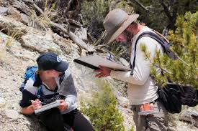

1. **Geological engineering:-**

Geological engineering is associated with anything constructed on or within the Earth. This discipline applies [geological](https://en.wikipedia.org/wiki/Geological) sciences and engineering principles to direct or support the work of other disciplines such as [civil engineering](https://en.wikipedia.org/wiki/Civil_engineering), [environmental engineering](https://en.wikipedia.org/wiki/Environmental_engineering), and [mining engineering](https://en.wikipedia.org/wiki/Mining_engineering). Geological engineers are involved with impact studies for facilities and operations that affect surface and subsurface environments, such as rock excavations (e.g. [tunnels](https://en.wikipedia.org/wiki/Tunnels)), [building foundation](https://en.wikipedia.org/wiki/Building_foundation) consolidation, slope and fill stabilization, [landslide](https://en.wikipedia.org/wiki/Landslide) risk assessment, groundwater monitoring, [groundwater remediation](https://en.wikipedia.org/wiki/Groundwater_remediation), mining excavations, and [natural resource](https://en.wikipedia.org/wiki/Natural_resource) exploration.